|  |
| --- |
| Run your own Census Create-a-thon! |

**CHECKLIST**

A resource from the Census Open Innovation Labs at the U.S. Census Bureau

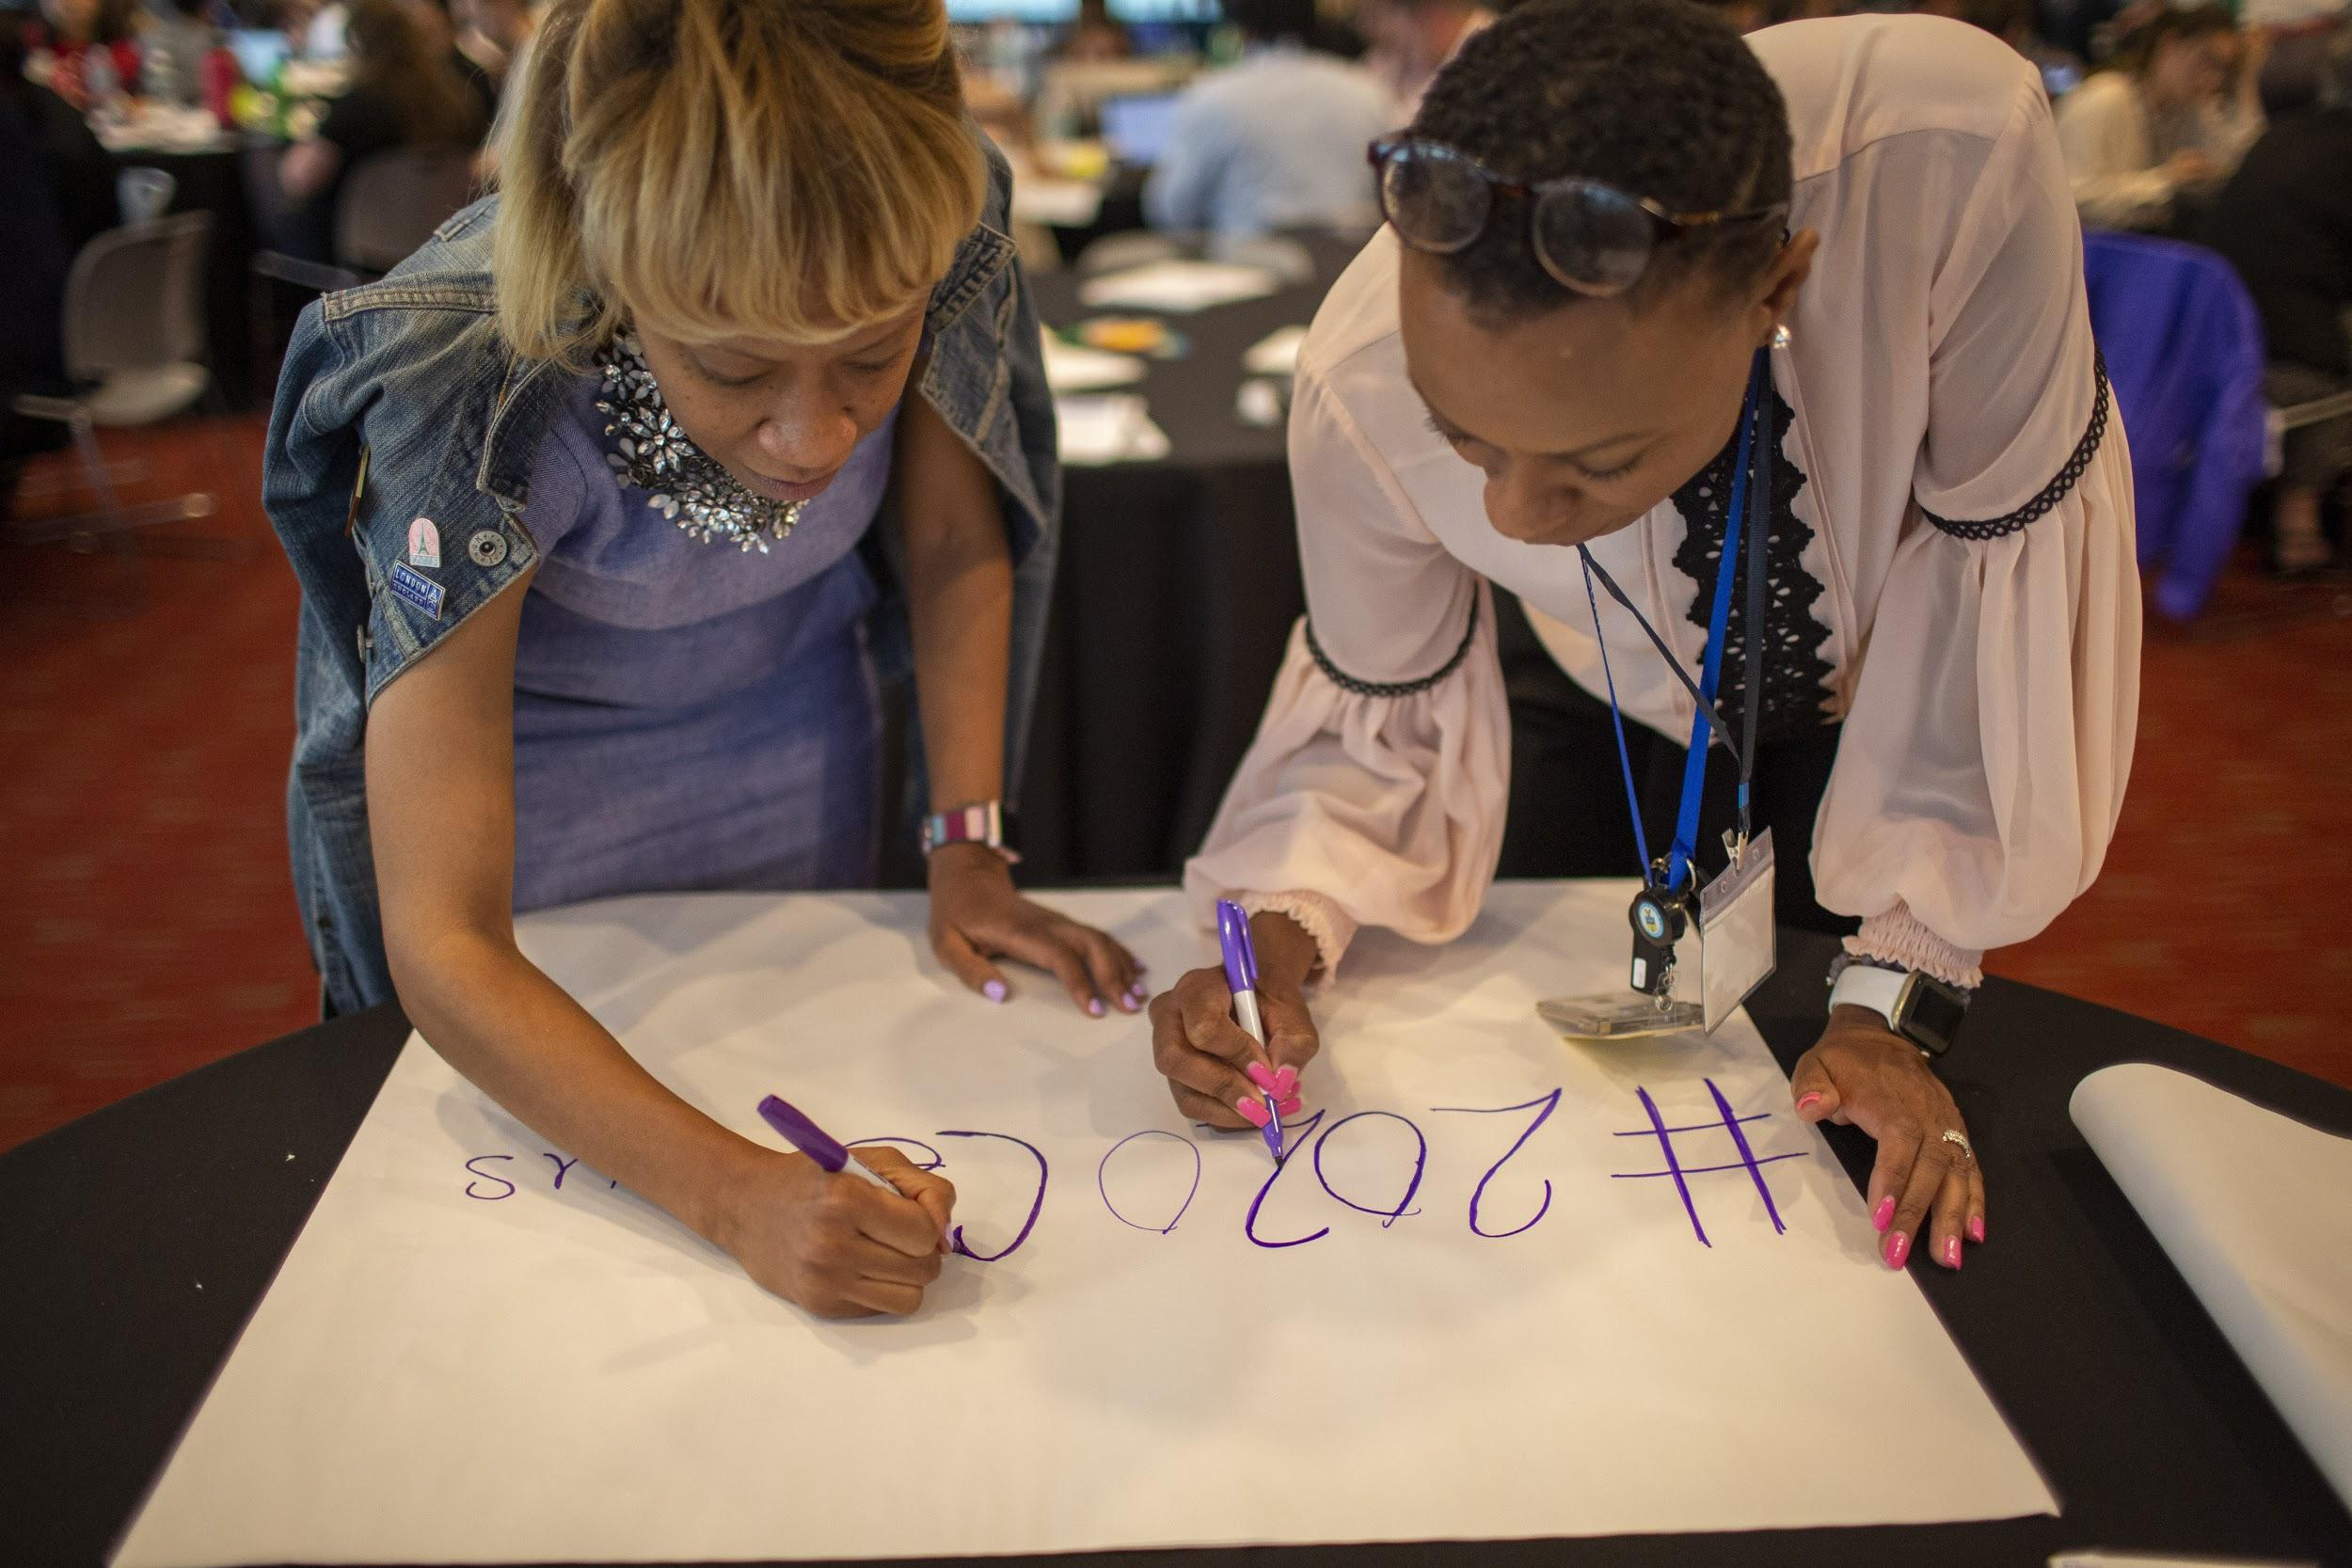

# **⎸Table of Contents**

* Secure partners and build your team
* Establish the basics
* Set up your invitation
* Conduct outreach
* Lock in event operations
* Refine your experience design
* Reach out to media / promotions / press
* Follow up after the event

# 

# ⎸Secure Partners and Build Your Team

### Form your event team:

* + Event Planner
  + Facilitator
  + Lead from community group that represents local or national hard-to-count community
  + Sponsorship Lead
  + Outreach and Marketing lead
  + Volunteer and Partnership lead
  + Food and Beverage Coordinator
  + Coordinator for post-event follow-up

### Get buy-in from:

* + Local Complete Count Committee
  + U.S. Census Bureau Regional Partnership Specialist
  + Organizations conducting Census outreach to hard-to-count community/ies (national, statewide, and local)
  + Creative networks: Local AIGA Chapter, University Design Departments, Meetups, etc.
  + National partners: tech platforms such as Facebook, Snap: how to optimize for platforms
  + A host - an event space, a company with a large meeting room, etc.
  + Sponsors for food, drinks, refreshments

# ⎸Establish the Basics

### Research and secure your venue. To hold an event, you’ll need a location that includes the following:

* + Tables
  + Seating
  + Power supply
  + Wi-Fi connection
  + Refreshments
  + Projector
  + Work with your event team and community partners to nail down an event space that works for your event style and agenda

### Set a date and time

* + Consider whether it’s feasible for your ideal attendees to attend on a week-day versus weekend, or morning versus evening.
  + Consider offering childcare on site at the event

### Determine your event length and customize your agenda.

↓

**SAMPLE AGENDAS**

|  |  |
| --- | --- |
| For a 5-hour event | |
| 0:00 - 0:30 | Check-in |
| 0:30 - 1:00 | Welcome |
| 1:00 - 2:00 | Briefing |
| 2:00 - 4:15 | Creating |
| 4:15 - 5:00 | Report back + Conclusion |
|  |  |
| For a 3-hour event | |
| 0:00 - 0:15 | Check-in |
| 0:15 - 1:00 | Welcome + Briefing |
| 1:00 - 2:30 | Creating |
| 2:30 - 3:00 | Report back + Conclusion |

# 

# ⎸Set Up Your Invitation

### Develop outreach list

* + Recruit for skill sets needed, including:
    - Members of the hard-to-count commmunity you’re addressing
    - Census experts
    - Graphic designers
    - Strategists and others with communication expertise
    - Community members with local knowledge
    - Loca media

### Create invitation:

* + [Splashthat](http://splashthat.com) is a good option for well-designed templates and a good back-end RSVP management system - and it’s free!
    - Here are some of the Create-a-thons hosted on Splashthat
      * El Paso: [http://bordercreativesforthecount.splashthat.com](http://bordercreativesforthecount.splashthat.com/)
      * South Carolina: [https://southcarolinaforthecount.splashthat.com](https://southcarolinaforthecount.splashthat.com/)
      * Pride in DC [https://censuspride.splashthat.com](https://censuspride.splashthat.com/)
    - We recommend using the theme called Sprout.
    - We recommend using images from local artists or murals as decoration on the page, always citing the source. We usually find these by Google Image.
    - [Check out this page with instructions on how to create and edit an event page on Splashthat.](https://support.splashthat.com/hc/en-us/categories/200163435)
  + Things to include on your event page:
    - * Time and date
      * Venue
      * Why the event is happening
    - Questions to include on your registration form
      * First Name
      * Last Name
      * Email
      * TItle
      * Organization
      * I want to participate as a … (check all that apply)
        + Strategist
        + Designer
        + Census Expert
        + Copywriter
        + Creative- other
        + Community advocate
        + Student
        + Community-based organization
      * So we can get a better sense of your relationship to Census, please rank on a scale of 1 to 5 your response to the following two questions (1 is not at all, 5 is extremely)
        + How equipped do you feel to explain the importance of Census 2020 to others in your community?
        + How equipped to you feel to develop content that reaches hard to count communities
      * Dietary restrictions or allergies? (if food is being served)
    - Here’s some boiler plate language you can use as you make your site and conduct your outreach

**CAN WE COUNT YOU IN?**

[PARTNER 1] and [PARTNER 2] will be joining forces with The Census Open Innovation Labs for [X STATE] first creative workshop to reach hard-to-count communities!

Over the course of [DURATION] informative and festive hours, we’ll dive into targeted briefs from local advocacy organizations, connect with a diverse group of talented people, and collaboratively generate digital media and compelling messages that spread awareness about the 2020 Census to communicate the importance of a complete and accurate count [X HARD TO COUNT COMMUNITIES.]

**THE NEXT CENSUS COUNT IS COMING IN 2020. SO WHAT’S THE BIG DEAL?**

We know the importance of voting and the impacts it has on our nation every election day. But what about the Decennial Census? The count of United States population sets our country’s trajectory for the next decade, determining congressional apportionment (the number of seats each state gets in the House of Representatives), redistricting, and how the allocation of close to $700 billion dollars is annually distributed annually to cities across the nation.

People of color, immigrants, LGBTQ people, people experiencing homelessness, rural communities, people with low incomes, renters, single- parent households, people with limited English proficiency, and young children are overwhelmingly undercounted in the Census. But we can help change that.

# ⎸Conduct Outreach

### Start spreading the word:

* + Develop template email for outreach
    - [Sample email here](https://docs.google.com/document/d/1ltRcBkWsMaBhXFd_bifWMbvbWBDaThgE0JWqglIeO2U/edit)
  + Send reminder / confirmation emails: two are recommended (e.g. one a week or two before; another the day before
    - [Sample emails here](https://docs.google.com/document/d/1ltRcBkWsMaBhXFd_bifWMbvbWBDaThgE0JWqglIeO2U/edit)
  + Reach out to the COIL team to set up a Slack Channel for your event, and encourage everyone to join the Slack channel in advance

# ⎸Lock in Event Operations

### Secure food, drinks, refreshments

### Do a walkthrough and make sure tables, chairs, A/V, are all in their right place.

* + Check for any unusual entrance requirements and note where signage needs to be placed.

### Order supplies:

* + [Pens - one per person](https://www.amazon.com/BIC-Round-Ballpoint-Medium-60-Count/dp/B0012YVGOW/ref=sr_1_4?keywords=Pens&qid=1562108664&s=office-products&sr=1-4)
  + [Different color sharpies - one per person](https://www.amazon.com/gp/product/B06ZZX41Q1/ref=ppx_yo_dt_b_asin_title_o06_s01?ie=UTF8&psc=1)
  + [Different color sticky notes - one stack for every 2-3 people](https://www.amazon.com/gp/product/B00CMKA9HK/ref=ppx_yo_dt_b_asin_title_o06_s01?ie=UTF8&psc=1)
  + [Large sticky easel pads (+ easels if there is no wall space)](https://www.amazon.com/gp/product/B00006IA9F/ref=ppx_yo_dt_b_asin_title_o06_s00?ie=UTF8&psc=1)
  + [Name tags](https://www.amazon.com/gp/product/B07535NQMY/ref=ppx_yo_dt_b_asin_title_o05_s00?ie=UTF8&psc=1)
  + [Different color dot stickers](https://www.amazon.com/gp/product/B07R12B3NX/ref=ppx_yo_dt_b_asin_title_o04_s00?ie=UTF8&psc=1) 
    - You will use these to indicate the skillset / role of participants -- to be placed on their name tag
      * E.g. Census expert, designer, storyteller, nonprofit / advocate

### Make a plan to print out materials

* + [Fact Sheets / 101](https://drive.google.com/open?id=1XFhT0CkC8KOS8GwtnYwUsB6DJQdR_0as)
  + Personas
  + Wifi login information
  + Bathroom signs (if needed)
  + Registration signs
  + Arrows to entrance (if not obvious)
  + [Commitment sheets](https://drive.google.com/open?id=1rm8WYitgfIYYT5oENIGtcEi9LdrIHLY_Hz0J9dilwpI)

### Coordinate with COIL team to set up a Slack Channel; #creativesforthecount is the general Slack team name. An event-specific channel can be set up within the #creativesforthecount Slack. This is where participants can upload content on the day-of, and maintain a dialogue with the event organizers and each before and after the event.

# ⎸Refine Your Experience Design

### Determine how you’ll be using personas

* + Determine whether you’ll be:
    - Asking individual groups to come up with their own personas by using the persona worksheet (better for shorter format events.)
    - Preparing personas, informed by user interviews (better for longer format events, or events where many attendees will not be familiar with the hard to count communities in discussion and need additional guidance)
      * Conduct user interviews with beneficiary organizations
        + [**User interview sample questions here**](https://docs.google.com/document/d/1cQJPQitfSQFeGuB8CBm5homyktEY2le1FAGLZAXXwmk/edit#)
      * Based on interviews, develop user personas
        + These describe the characteristics, mindsets, and behaviors of people that partner organizations are trying to reach. They help anchor the create-a-thon participants in the human elements of digital outreach.
      * [**Sample user personas here**](https://docs.google.com/presentation/d/1v5D3Yeh7xTJS5TY5jOv9ZJYnRKaDMxoAWaJwVoTb-oU/edit#slide=id.g5b4170b7e8_0_82)

### Determine who will be giving opening remarks

* + Someone to welcome everyone to the venue
  + Someone to give an overview on why Census matters to this particular place or hard to count community, including slides

### Develop run-of-show (based on desired outcomes, and allotted time)

* + [**Sample run-of-show here**](https://docs.google.com/document/d/1BpACFZGJzNfCmX4WBPcEWZDXXTpclcx5ReuWkMsVbVk/edit) 
    - Arrivals, networking, grabbing food
    - Speakers (keep to ~30 min. total)
    - Breakout group work
      * Ice breakers
      * Persona review
      * Ideation / brainstorming
      * Optional crash course in content development
      * Create-a-thon
    - During the create-a-thon, participants upload content onto the Slack channel and the Rock The Vote site, <https://www.creativesforthecount.org/>. Content on this site don’t appear live immediately, as the content is moderated.
      * For static files:
        + image/jpeg, image/jpg, image/png, image/gif, .eps, .psd, .ai, .indd, .sketch
      * For editable files:
        + Photoshop, Illustrator, Indesign, AfterEffects, Sketch, Canva
    - Share-outs and wrap-up
    - Reception / networking / celebration (optional)

# ⎸Reach out to media and press

### Secure a photographer or videographer if you wish to document the event

* + Some university students may be willing to do this at low/no cost

### Social media - draft sample tweets / posts in advance

* + Sample Tweets: [1](https://twitter.com/uscensusbureau/status/1142054602445119489), [2](https://twitter.com/uscensusbureau/status/1139272482052083719), [3](https://twitter.com/uscensusbureau/status/1139267448887283715), [4](https://twitter.com/uscensusbureau/status/1139236110016622592)
  + Sample Instagram posts: [1](https://www.instagram.com/p/BysL9NFgGNH/)**,** [2](https://www.instagram.com/p/ByqOd9NgU3g/), [3](https://www.instagram.com/p/ByqTB7ZAOPx/)

### Reach out to local news, media, or other local influencers

# ⎸Follow Up After the Event

* Send a thank you + followup email as soon as possible following the event
  + [**Sample email**](https://docs.google.com/document/d/1ltRcBkWsMaBhXFd_bifWMbvbWBDaThgE0JWqglIeO2U/edit)
* Transcribe commitment sheets and share results with the COIL team
* Make a plan for who will follow up on commitments and when
* Share photos, media with appropriate stakeholders
* Share outputs with COIL: [census.accelerate@census.gov](mailto:census.accelerate@census.gov)
* Write a Medium post, blog entry on organizational website, or other post-event recap
* Send thank you notes to any hosts/sponsors/partners